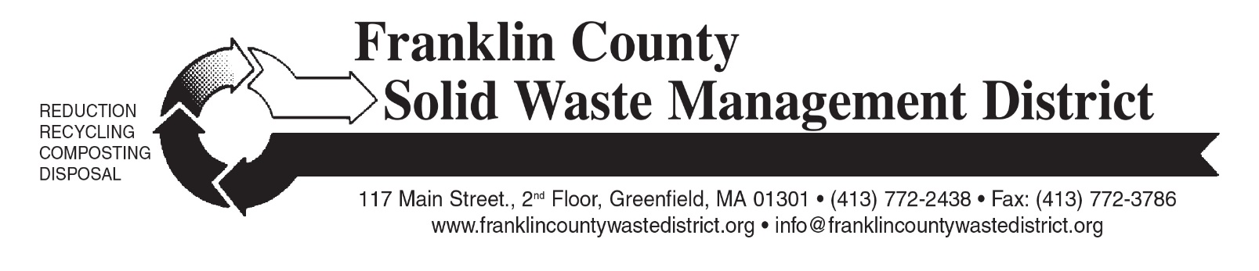

Clothing and Textiles banned from trash
State Waste Ban begins November 1st

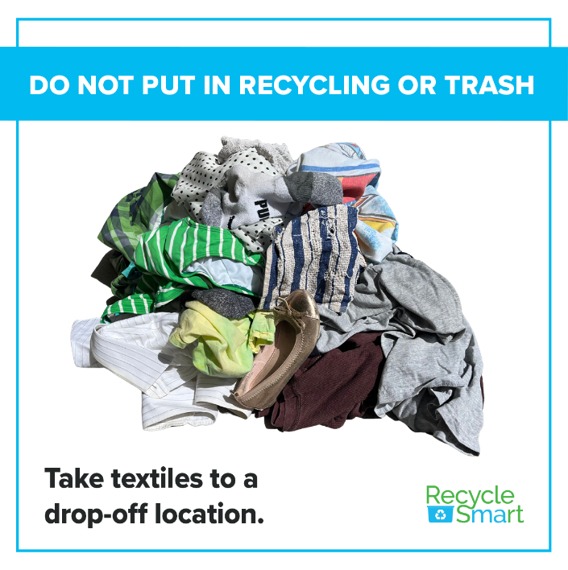
As of November 1, 2022, clothing and other textiles will no longer be allowed in the trash in Massachusetts. New state “waste ban” rules require textiles be kept out of the trash so they can be reused or recycled.
Residents should place clean, dry clothing, textiles and footwear in a plastic bag and bring to a textiles drop off location. Never place textiles in a recycling bin.
What is banned from the trash and accepted in textile drop-off locations? Textiles are defined as anything from clothing (shirts, sweaters, pants) to footwear (sneakers, sandals, cleats) to accessories (bags, belts, hats) to linens (sheets, towels, fabric, and more). These items can be torn, stained, out of style, or missing a mate, but they must be CLEAN and DRY. Items that cannot be reused or sold in thrift stores are sorted, baled and sold to recyclers who make insulation, padding, and wiping cloths. To see a longer list of accepted items, please visit: franklincountywastedistrict.org/p/68/Textiles
To retain their reuse value and avoid mildew contamination, all textile donations must be clean and dry. Keep them dry by placing in a plastic bag and tying it up. Textiles that are contaminated with mold, bodily fluids, insects, oil, or hazardous substances may go in the trash.
There are many local drop-off locations. Textile drop boxes accept the widest range of items; smaller, independent resale shops may be more restrictive in what they want. Some organizations will even pick up from your home.

Every municipal transfer station in Franklin County hosts a textiles drop box for their residents or permit holders. Some transfer stations might require access fees or annual permits. These 19 transfer stations are in: Ashfield, Bernardston, Buckland, Charlemont, Colrain, Conway, Deerfield, Greenfield, Heath, Leverett, Montague (Turners Falls), New Salem, Northfield, Orange, Rowe, Shelburne, Warwick, Wendell, and Whately. In addition, textile recycling is now accepted at local Salvation Army Thrift Stores.
The 2030 Solid Waste Master Plan by the Massachusetts Department of Environmental Protection (MassDEP) aims to reduce solid waste disposal statewide by 30 percent over the next decade, from 5.7 million tons in 2018 to 4 million tons in 2030. MassDEP is expanding the state’s current waste disposal bans by adding textiles to the list of materials banned from disposal or transport for disposal in Massachusetts. See the list of banned materials here: https://www.mass.gov/doc/fact-sheet-what-are-the-massachusetts-waste-bans/download
Clothing and textile products amount to 6% of all material going into U.S. landfills and incinerators…that’s 230,000 tons annually in Massachusetts alone! 95% of all used clothing, footwear, and other household textile products can be reused or recycled, yet only 15% of reusable textiles are currently recovered from the waste stream.
Trash disposal capacity is extremely limited in Massachusetts. Diverting recyclable (and compostable) materials from the trash conserves our limited landfill space and saves money. The few remaining landfills in the state are scheduled to fill up and permanently close within a few years. Most of the “waste-to-energy” trash incinerators in Massachusetts are operating at full capacity. Earlier this year, the two waste incinerators in western Mass went bankrupt and closed; that trash is now being sent to landfills in faraway states such as Pennsylvania and the Carolinas. Trash disposal is expensive for municipalities and waste haulers, and due to longer travel distances, trash costs are rising.
Close the loop: the next time you are planning to purchase of a new item of clothing, please consider visiting local or online secondhand clothing stores before buying new.
For more information, visit franklincountywastedistrict.org, email info@franklincountywastedistrict.org or call 413-772-2438. MA Relay for the hearing impaired: 711 or 1-800-439-2370 (TTY/TDD).

